Supporting information

Self-assembling peptide nanofiber scaffolds for controlled release governed by gelator design and guest size

Ying Zhao ^{a,b}, Masayoshi Tanaka ª, Takatoshi Kinoshita ^{a,∗}, Masahiro Higuchi ª, Tianwei Tan ^{b,∗}

ª Department of Materials Science and Engineering, Graduate School of Engineering, Nagoya Institute of Technology, Gokiso-cho, Showa-ku, Nagoya 466-8555, Japan
^{b} College of Life Science and Technology, Beijing University of Chemical Technology, 15 Beisanhuan East Road, Chaoyang District, Beijing 100029, China

Materials for peptide synthesis:
Fmoc-Amid Resin for solid phase synthesis was purchased from Applied Biosystems Inc. (CA, USA). Fmoc-protected amino acids (Fmoc-Arg(Pbf), Fmoc-Ala∙H₂O, Fmoc-Asp(OBu^{t}), and Fmoc-Phe) were supplied by Peptide Institute, Inc. (Osaka, Japan). Solvents required for synthesis such as Dichloromethane (DCM, peptide synthesis grade), and N-Methylpyrrolidone (NMP, peptide synthesis grade) were acquired by Applied Biosystems Inc. (CA, USA). Coupling reagents were obtained by the following sources: piperidine (99.5+%, Biotech grade) by Sigma-Aldrich (Missouri, USA), HBTU by Applied Biosystems Inc. (CA, USA), and N-Diisopropylethylamine/N-Methylpyrrolidone (2.0 M, peptide synthesis reagent) by Applied Biosystems Inc. (CA, USA). The N- and C-terminal of the peptide were acetylated and amidated to eliminate terminal charges which will complicate the self-assembly process. This modification might also provide resistance against exopeptidase which recognizes the free amino- and carboxy-terminal for future in vivo applications. The chemicals used during the N-terminal modification were acetic anhydride and pyridine (lab grade) supplied by Nacalai Tesque. Inc. (Tokyo, Japan). Reagents used for cleavage of the peptides from the resin were: trifluoroacetic acid (TFA, lab grade) and thioanisole (TAS, ≥ 99%) by Nacalai Tesque. Inc. (Tokyo, Japan), 1,2-ethanedithiol (EDT, ≥ 98%) by Tokyo Kasei Kogyo Co., Ltd. (Tokyo, Japan). Solvents for precipitation such as diethyl ether and methanol (lab grade) were supplied by Nacalai Tesque. Inc. (Tokyo, Japan). Additional chemicals used during the preparation for molecular weight measurement were: α-cyano-4-hydroxycinnamic acid (CHCA, ≥ 97%) by Sigma-Aldrich (Missouri, USA), TFA, acetoneitrile, and di-Ammonium Hydrogen Citrate (lab grade) by Nacalai Tesque. Inc. (Tokyo, Japan).

Table S1
Properties of model guests.
Compound | Chemical Structure | Molar Weight (MW) | logP ^{[1]}
Phenylalanine (Phe) | 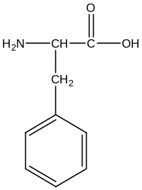 | 165.19 | -1.43
Tryptophan  (Trp) | 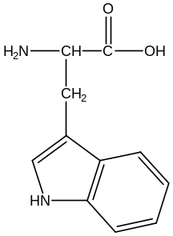 | 204.23 | -1.04
Phenol Red  (PR) | 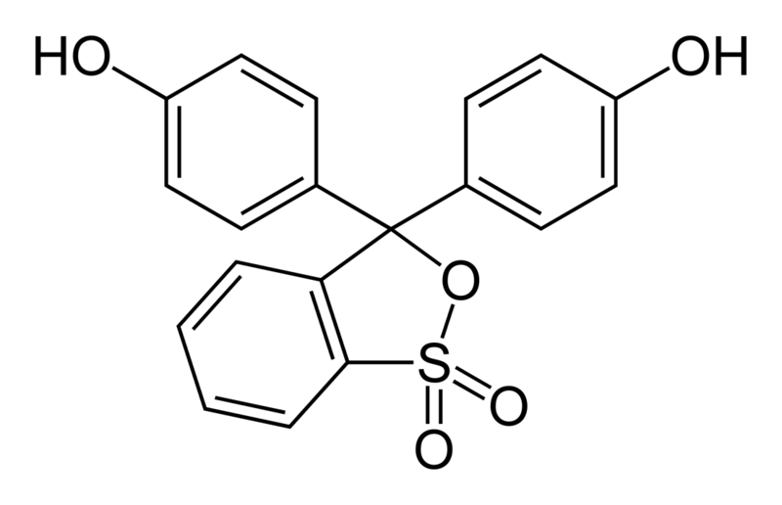 | 354.38 | 0.576

References
[1] J.W. Lee, T.P.B. Nguyen, H. Moon, Adsorption and desorption of phenylalanine and tryptophane on a nonionic polymeric sorbent, Korean J. Chem. Eng. 23 (2006) 812-818.

